**Geethanjali College of Engineering and Technology**

**(Autonomous)**

**(Approved by AICTE, permanently affiliated to JNTUH, accredited by NAAC with ‘A’)**

**Cheeryal(V), Keesara(M), Medchal Dt., Telangana-501301**

PBL report on application for maintenance of details of research, patents and projects of Faculty

For the course: Objected Oriented Programming

Submitted by : D. Sree Sai Soujanya (20R11A0573), G.Phalguni (20R11A0576)

Under the guidance of **:** A. Sree Lakshmi (HOD CSE)

Department of

Computer Science and Engineering



**I**.**Acknowledgement**

Building the application titled “Application for maintenance of details of research, patents and projects of Faculty ” was a great learning experience for us. The success and outcome of the project and report were possible with the obliging guidance of our HOD, Prof. Dr. A Sree Lakshmi. We are incredibly privileged to have got this along with the success of the project.

We appreciate and thank Prof. Dr. A Sree Lakshmi for the opportunity and support. We would like to express our sincere gratitude for the assistance provided, despite having a busy schedule due to the enduring college affairs. Under the supervision of our HOD we have built an efficient software that facilitates maintenance of data.

**II. Introduction**

Most of the engineering colleges maintain faculty data related to research, projects and acquired patents. Keeping track of such information is significant and useful. It helps in tracking research capabilities of the faculty. Also, such information has to be submitted to government organizations like NAAC, NBA and ranking frameworks like NIRF that assess and accredit Higher Education Institutions.

Maintenance of such huge data becomes tedious when data is stored in written format. Preserving all the files and papers can be challenging. It is difficult to draw insights from the data maintained in such format. Handling inaccuracies, separation of data and its classification is arduous.

Digitalization of storage and maintenance of data is a better technique as it helps and enhances the complete storing and visualizing mechanism. The application software built, enables maintenance of details of faculty’s research information, patents, and projects. The modules in the project allow the user to insert, update, delete and retrieve the data. The operations are performed and the results are displayed on the interface. The data is stored in the database. Password lock is enabled for authentication purpose. Data manipulation either by insertion, update and deletion operations is allowed only when authentication succeeds.

**III. Technologies Used:**

**Front-end :**

* Java

**Back-end:**

* MySQL
* SQL
* JDBC
* Mysqlconnector

**IV.Design**

**1.Modules/Frames**

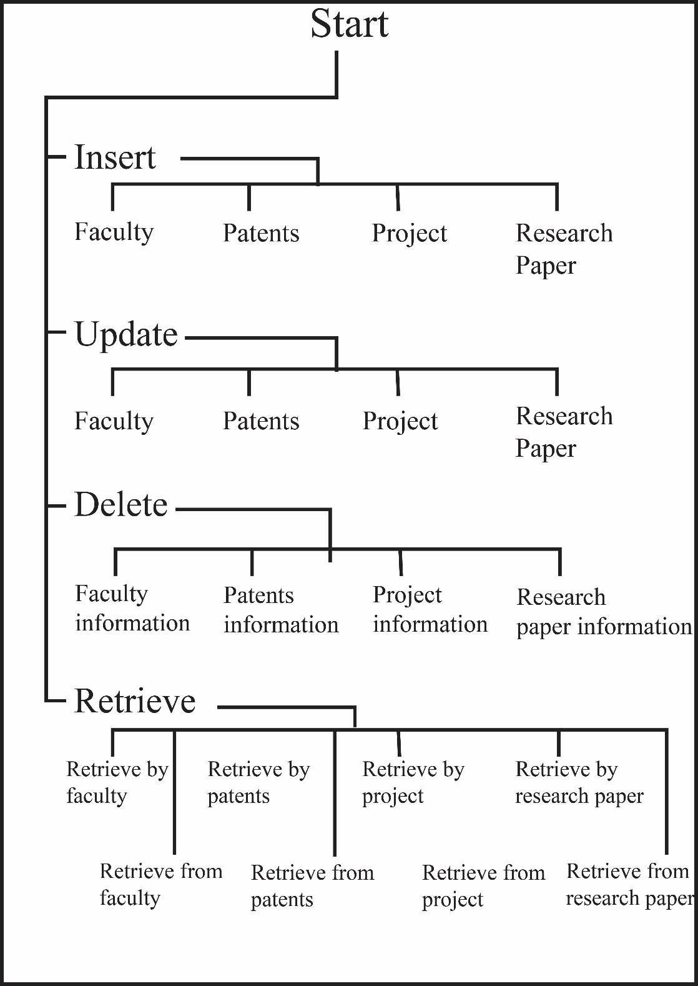

Start is the main module. Via the start module traversal to Insert, Update, Delete and Retrieve modules can be done. Insertion of data into the database can be performed using the functionalities provided in this module. Similarly, update module aids update operation. Delete module assists deletion of information from the database. Visualization of information from the database can be done using the retrieve module.

**2.Database design:**

**Table 1: Faculty**

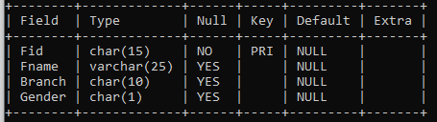

Primary key: Fid

**Table 2: Project**

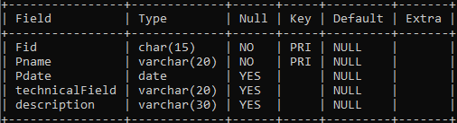

Primary key : Fid,Pname

Foreign key: Fid ( reference Faculty table)

**Table 3: Patents**

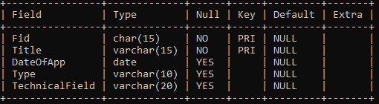

Primary key: Fid, Title

Foreign key : Fid ( reference Faculty table)

**Table 4: Research Paper**

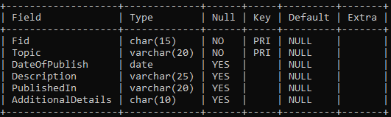

Primary key: Fid, Topic

Foreign key : Fid ( reference Faculty table)

**V.Implementation**

**Modules**

**1. Start**

Start frame is the parent frame. It is the main and first interface user views when the software is run. Traversal to Insert, Delete, Retrieve and Update frames are to be done from the start frame.

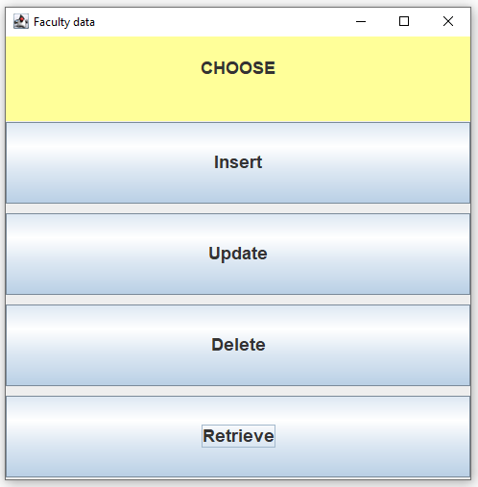

**2. INSERT**

**Functionality-**

This frame facilitates **INSERT** operation.Data of the faculty is stored in the database and insertion is performed with the options provided in this frame. Buttons back and close are provided to traverse through the frames and close frames respectively.

If the data to be inserted already exists, it displays a dialog box as follows:

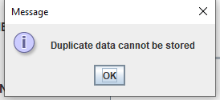

Else it shows the following dialog box:

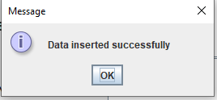

Insert module displays a frame where the user can choose the table onto which the details are to be inserted.

It provides the following options:

1.Faculty

2.Project

3.Patent

4.Research paper

The following frame is displayed:

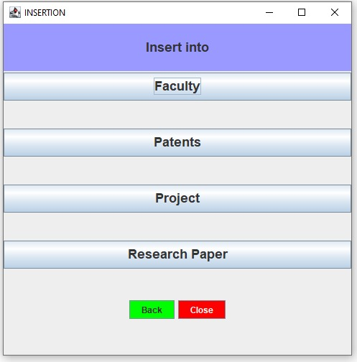

**2.1-Insert Faculty**

Insert Faculty module has 4 text fields with 4 respective labels through which the user can insert the details

1.FacultyId

2.Faculty Name

3.Faculty Branch

4.Faculty Gender

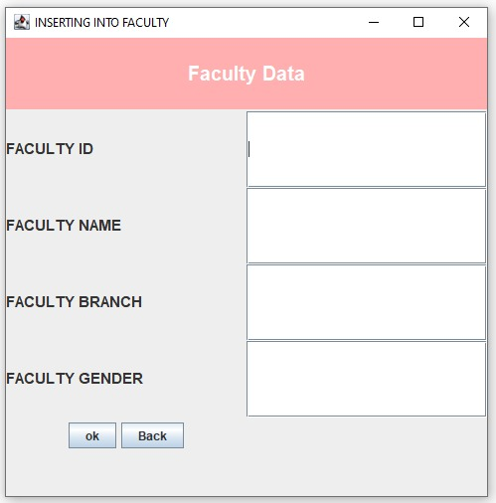

**2.2-Insert Patents**

Insert Patents module has 5 text fields with 5 respective labels through which the user can insert the details

1.Patent Title

2.Patent Type

3.Faculty ID

4.Technical Field

5.Date Of Application

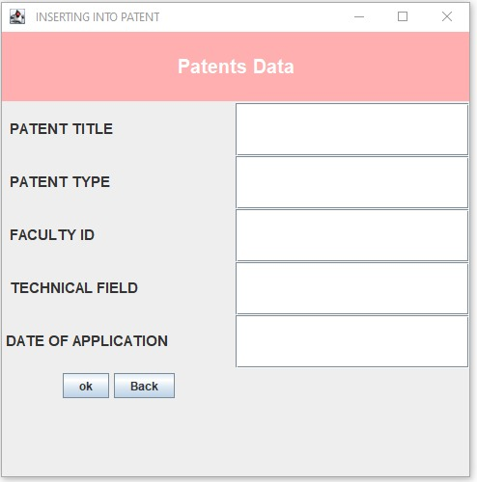

**2.3-Insert Project**

Insert Project module has 5 text fields with 5 labels where the user can enter the details.

1.Project Title

2.Project Date

3.Faculty ID

4.Technical Field

5.Project Faculty ID

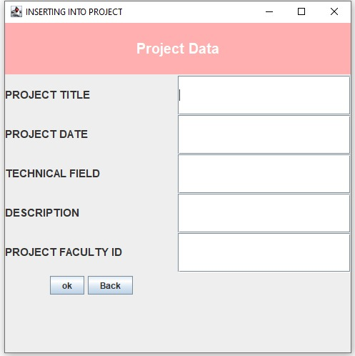’

**2.4-Insert Research**

Insert Research module has 5 text fields with 5 labels through which the user can insert the details

1.Topic

2.Date Of Publish

3.Faculty ID

4.Published In

5.Paper Description

This frame has Radio Button that allows the user to select the type of research paper.

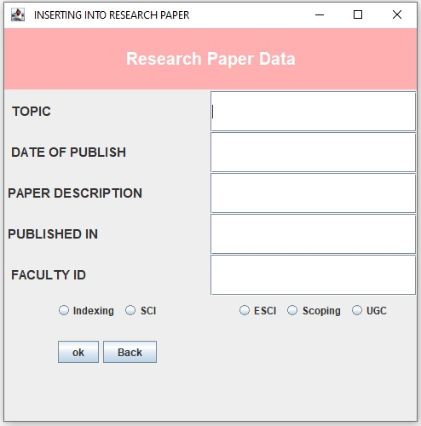

**3.UPDATE**

**Functionality**- This frame facilitates UPDATE operation.

Data of the faculty is updated in the database with the options provided in this frame. Buttons back and close are provided to traverse through the frames and close frames. UPDATE module displays a frame where the user can choose the option and update the related details.

It provides the following options:

1.Faculty 2. Project 3.Patent 4.Research paper

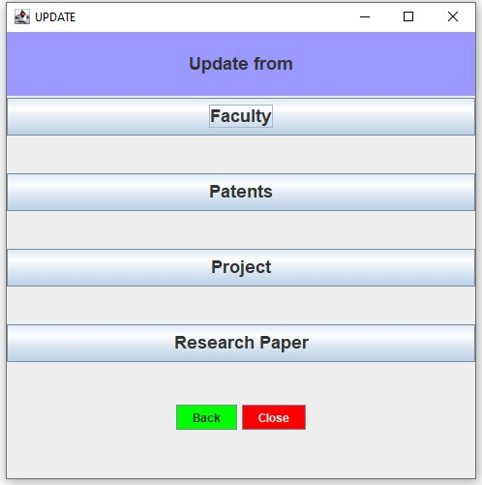

**3.1-UPDATING FACULTY**

Updating Faculty module has 3 buttons:

1.Faculty Name 2. Faculty branch 3. gender

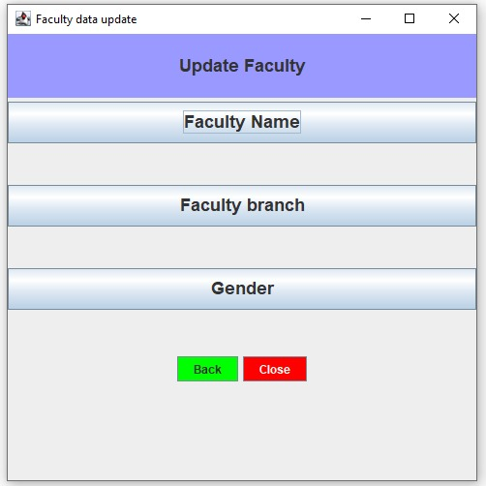

**UPDATING FACULTY NAME**

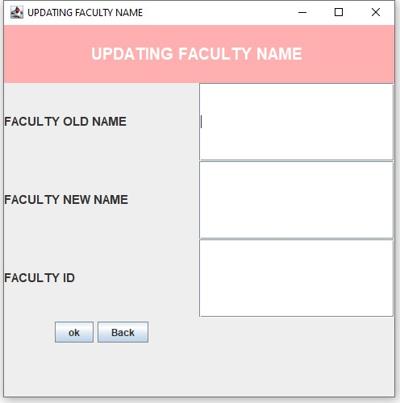

**UPDATING FACULTY BRANCH**

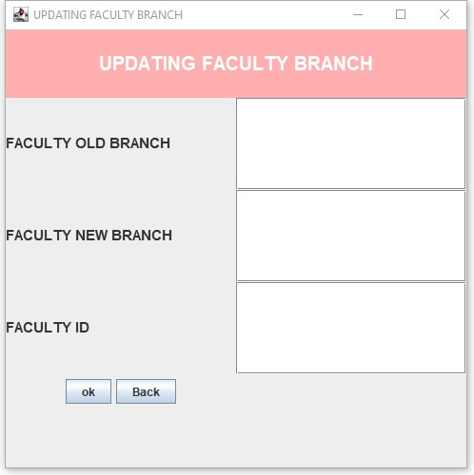

**UPDATING FACULTY GENDER**

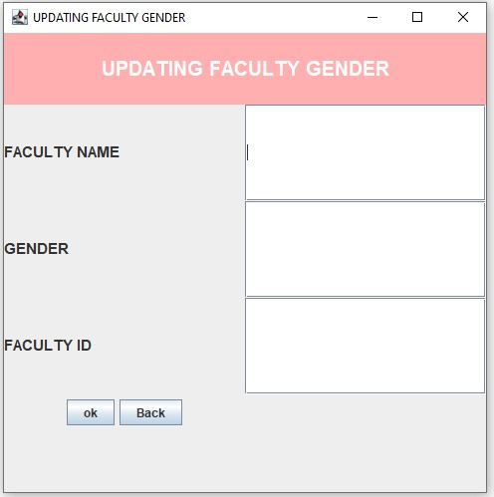

**3.2-UPDATING PATENT**

Updating patent module has 4 buttons. The user can select the required button and update the details. New data overwrites the old data.

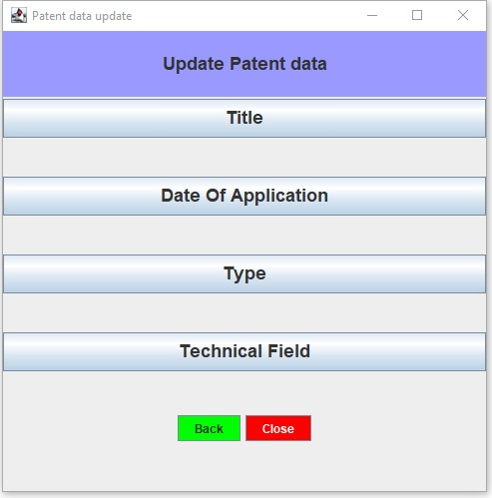

**UPDATING PATENT TITLE**

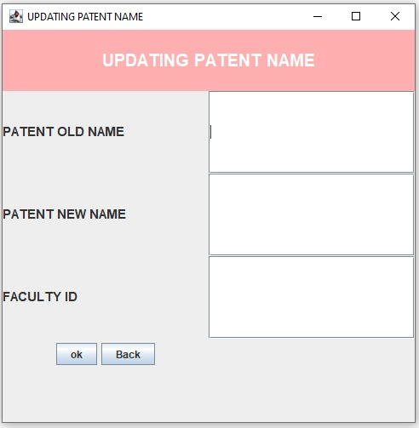

**UPDATING PATENT TYPE**

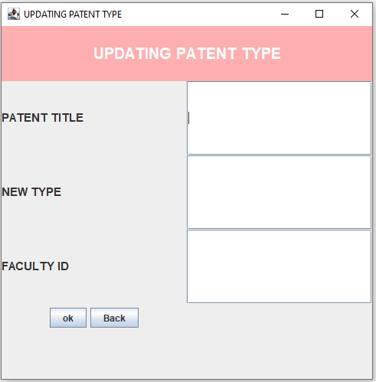

**UPDATING PATENT DATE OF APPLICATION**

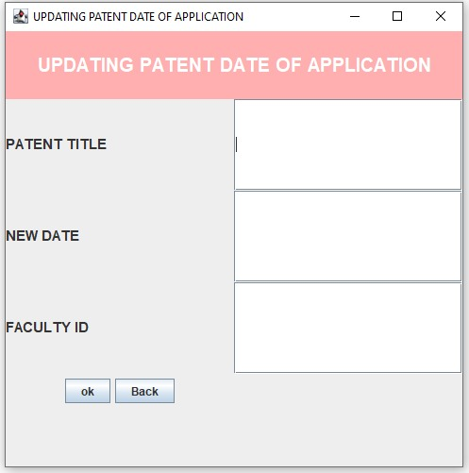

**UPDATING PATENT TECHNICAL FIELD**

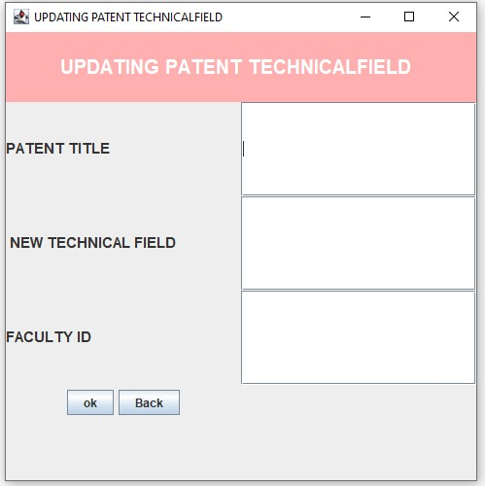

**3.3-UPDATING PROJECT**

Updating PROJECT module has 4 buttons through which the user can select the required button and update the details.

It has 4 buttons:

1.Project Title 2.Project Date 3.Technical Field 4.Description

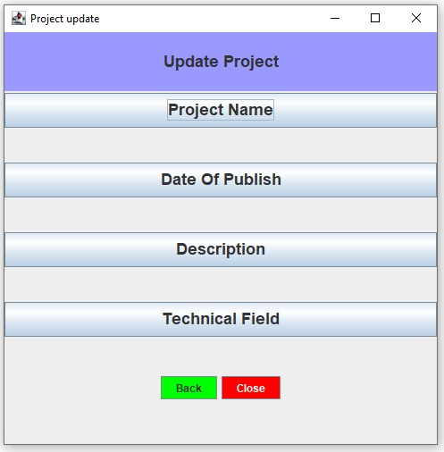

**UPDATING PROJECT TITLE**

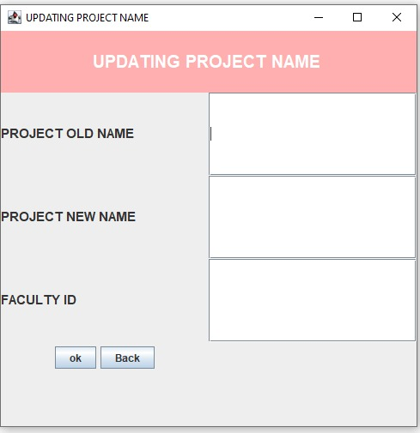

**UPDATING PROJECT DATE**

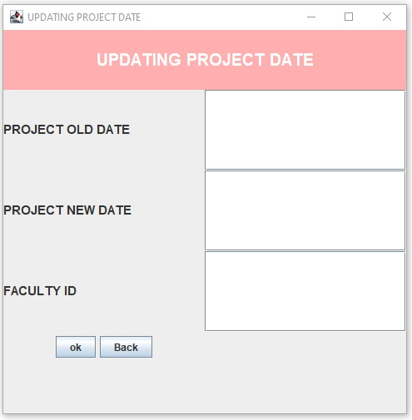

**UPDATING PROJECT TECHNICAL FIELD**

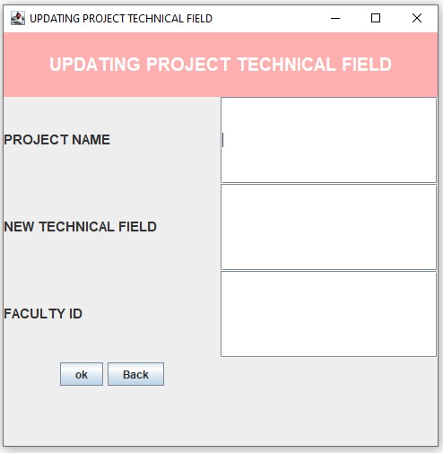

**UPDATING PROJECT DESCRIPTION**

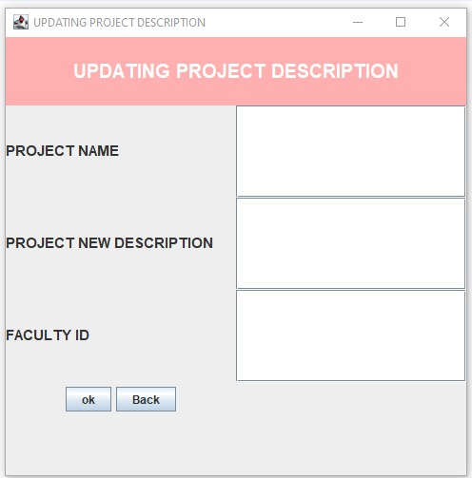

**3.4-UPDATING RESEARCH PAPER**

Updating RESEARCH PAPER module has 4 buttons :

1.Topic 2. Date Of Publish 3.Paper Description 4.Published In

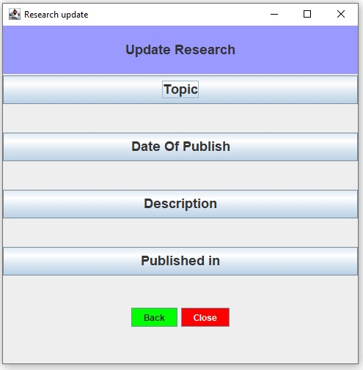

**UPDATING RESEARCH TOPIC**

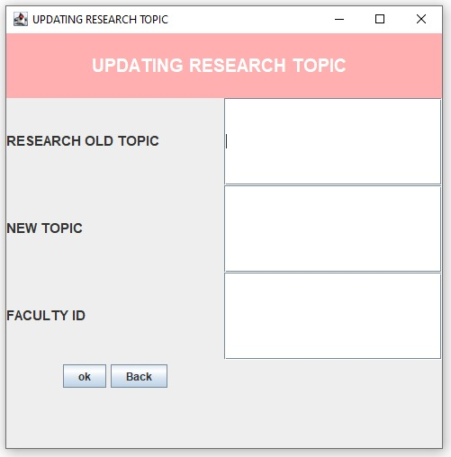

**UPDATING RESEARCH DATE OF PUBLISH**

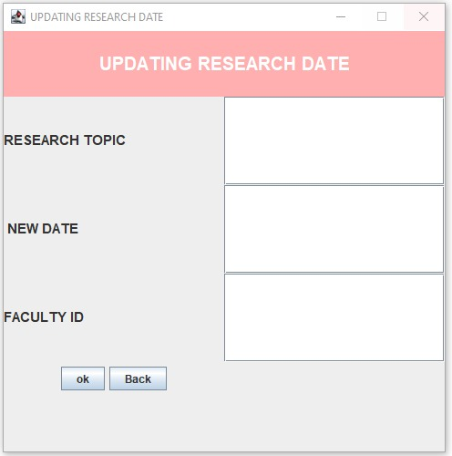

**UPDATING RESEARCH PAPER DESCRIPTION**

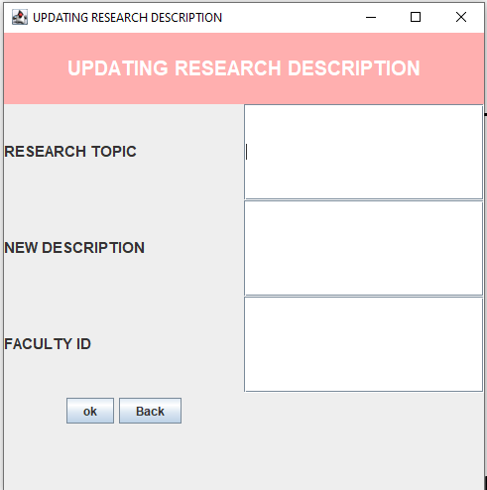

**UPDATING RESEARCH PAPER PUBLISHED IN ATTRIBUTE**

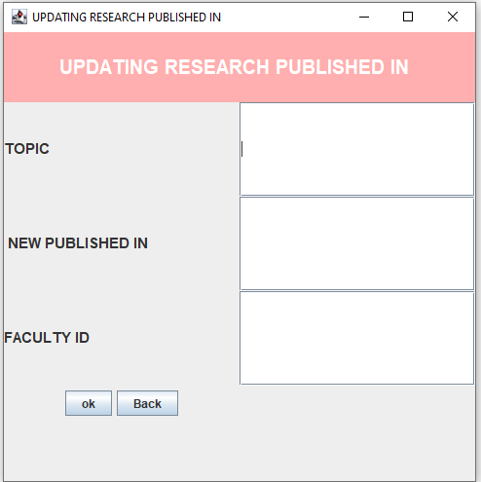

**4.Deletion**

**Functionality**: This frame facilitates delete operation. Data of the faculty stored in the database can be deleted via the options provided in this frame. Buttons back and close are provided for forward and backward traversals through the frames.

* Delete

Delete module displays a frame where the user can choose that part of the table from which information has to be deleted.It provides the following options:

Delete:

1. Faculty information
2. Project information
3. Patent information
4. Research paper information

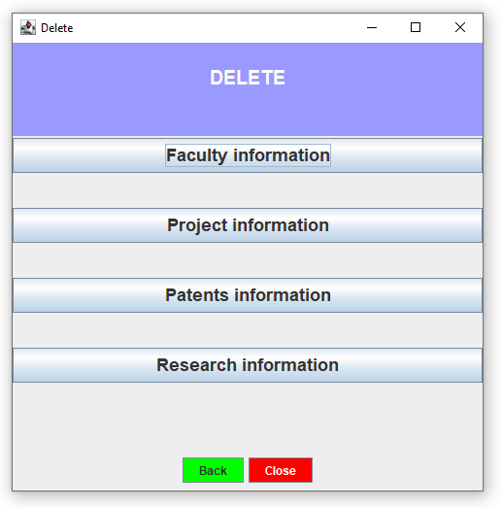

**DeleteDataVisual**

DeleteDataVisual module performs two functions:

Firstly, it provides an interface to select the information that has to be deleted from the database.

Secondly, it performs deletion (backend) where the chosen information, if available in the database, gets deleted.

1.Interface (Deletion)

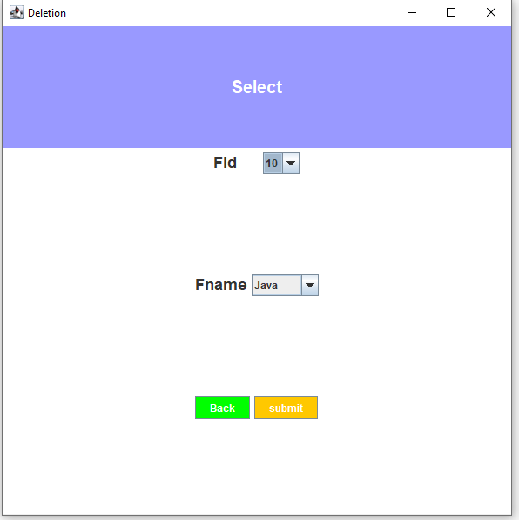 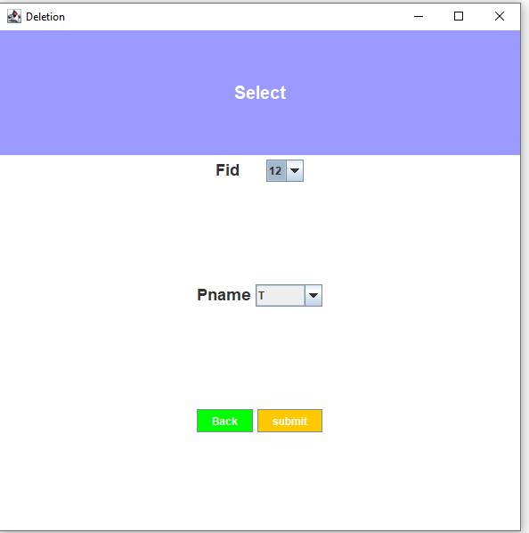

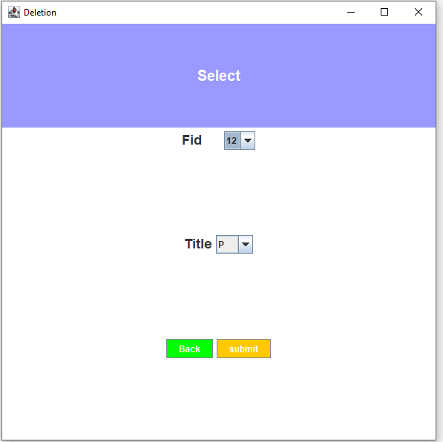 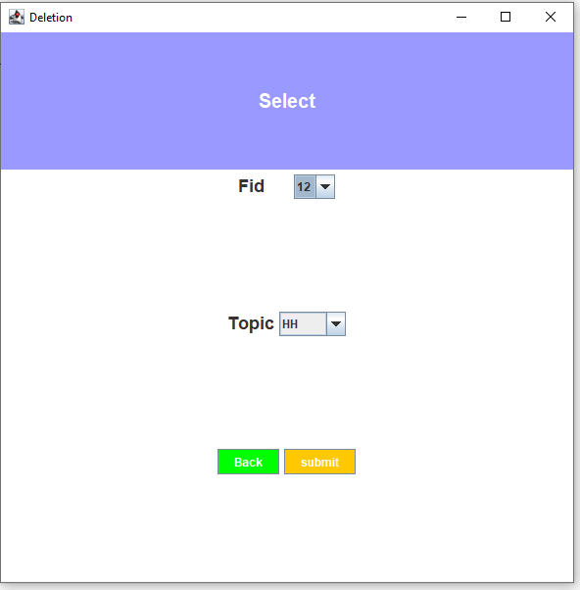

User selects the information to be deleted and clicks on submit. Submit button instigates the second functionality of the DeleteDataVisual module which is elaborated below.

2. Deletion of data from database

When the selected information is available in the database it aids the deletion of data from the database. When the operation succeeds, a dialog box confirms its completion to the user. On any error or exception or fault, the operation fails and the user is informed about the same.

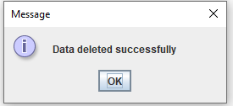

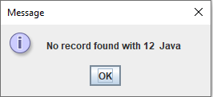

**5.Retrieval**

Retrieval selects the required part of the database and displays it to the user in a systemic way. There are three modules that implement the retrieval operation. They are:

**5.1-RetrieveAll**

It is a frame.

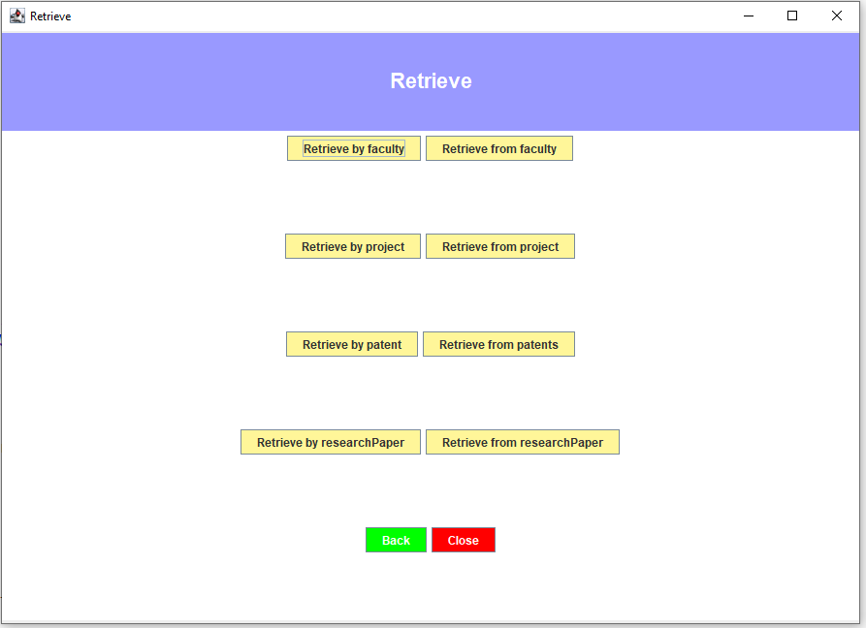

User is provided with an interface where the user can select the information that has to be displayed. On selection, GetResultSet module is called and required information is passed from this to module to GetResultSet module.

**5.2-GetResultset**

GetResultSet module is invoked by RetrieveAll module. It identifies the part of the database that has to be displayed. Then, it gathers required information and tuples to be displayed from the database. The obtained information is passed to TableGenerator module which displays the data in the form of a table.

**5.3-TableGenerator**

This module is called by GetResultSet module. The data retrieved from the database is displayed in the form of a table.

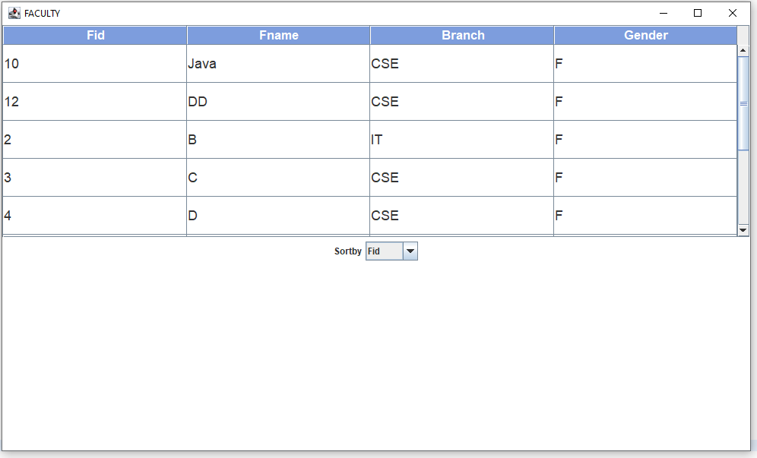

It also provides **sort by** functionality using which the data can be sorted for better viewability and clarity.

**6.PasswordVerification**

Insert, delete and update operations directly deal with the data in the database, they have the potency to make the database inconsistent. To maintain the consistency of the database, only selected users must be allowed to manipulate the data. Also, some data in the database must be kept private for security reasons. In order to achieve both the mentioned objectives, a password frame is maintained in order to allow only authorized users to work with the mentioned operations.

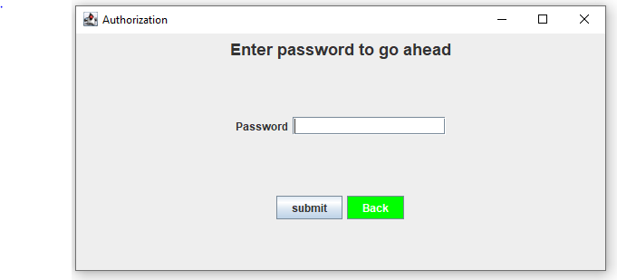

When the user enters the password, the entered password is verified. If the verification is a success (when entered password is right), the user is taken to the respective frame for deletion/insertion/update.

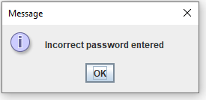Else, the user is not permitted to go ahead.

**VI.Testing**

**A) Insert:**

1.Trying insertion of duplicate data:

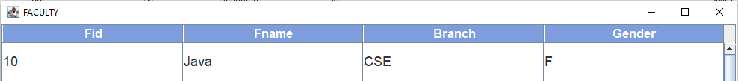

Insertion of duplicate data is rejected as faculty id is the primary key.

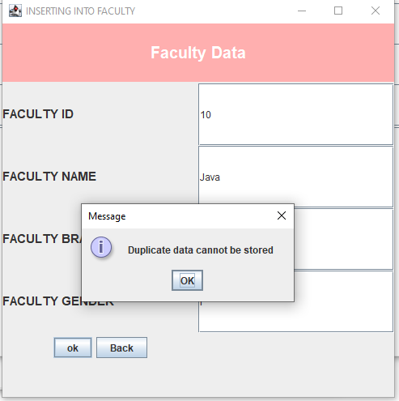

2.Trying insertion of unique data (Typical insertion operation):

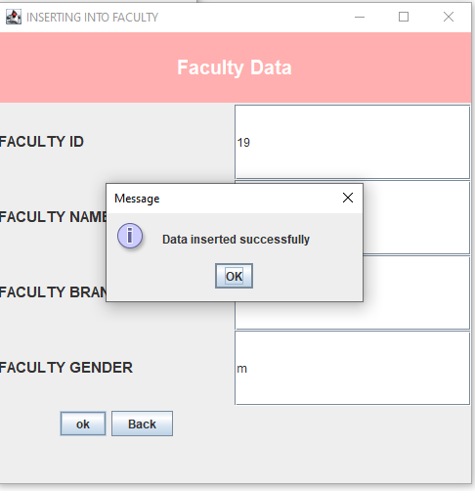

Insertion proceeds successfully as data is unique

3. Clicking submit without entering data:

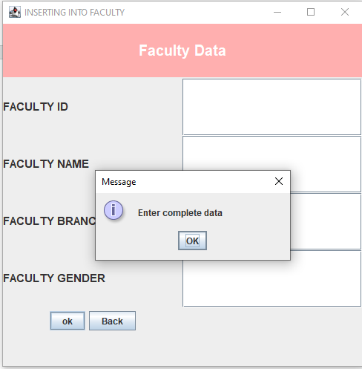

Insertion does not proceed as a dialog box pops that says, “Enter complete data”.

**B) Delete**

1.Deletion of a combination that does not exist in the database

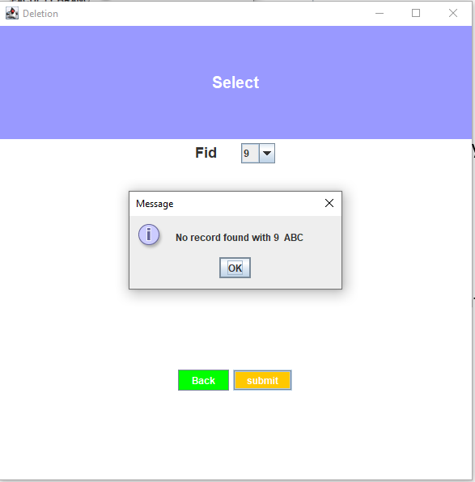

2.Deletion of a combination that exists in the database

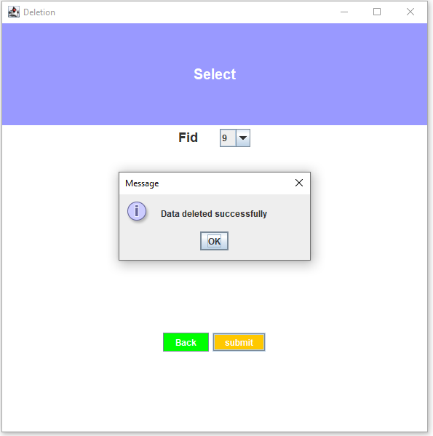

**C) Password verification**

1. When entered password is right:

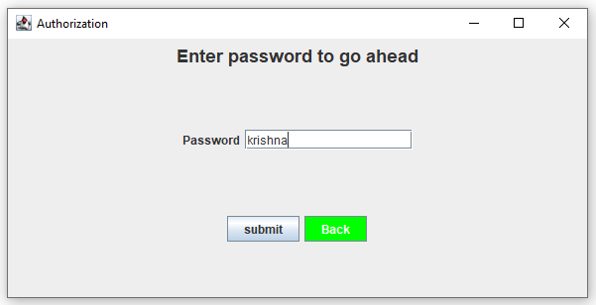

The user is taken to the corresponding frame.

1. When password entered is incorrect

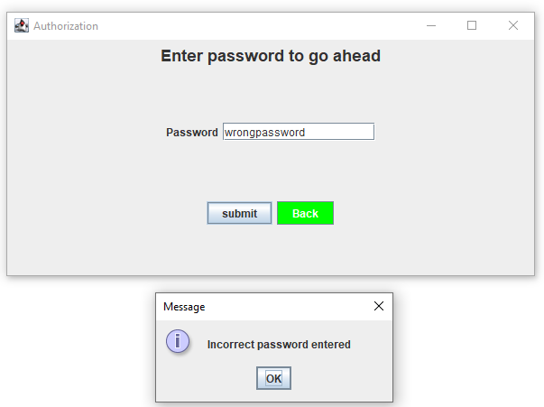

1. Clicking submit without entering any text in the password field

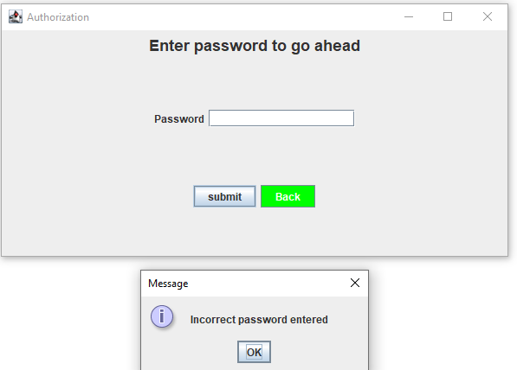

**D) Retrieve**

Searching for a single entity:

1. When entered data is not owned by any faculty/project/research paper/patent:

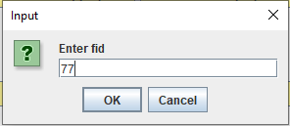 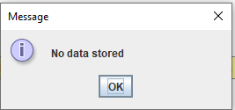

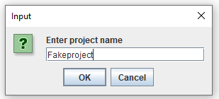 

2.When entered data is owned by some faculty/project/research paper/patent:

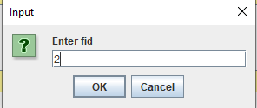

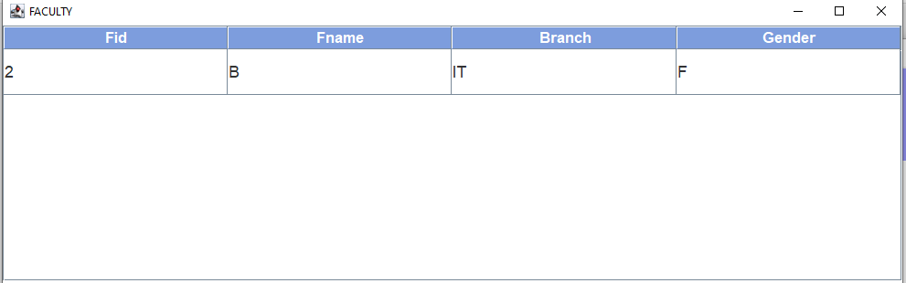

Retrieving all information :

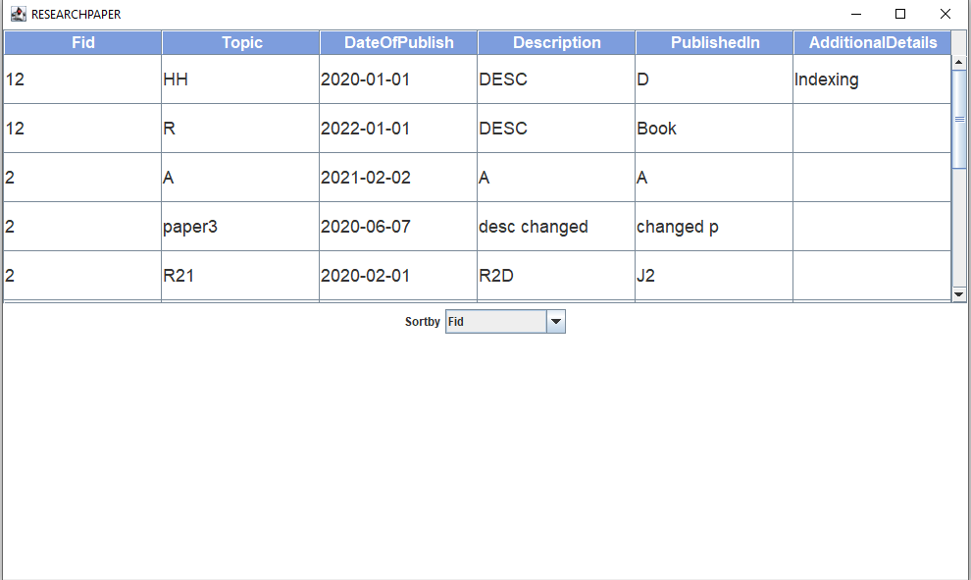

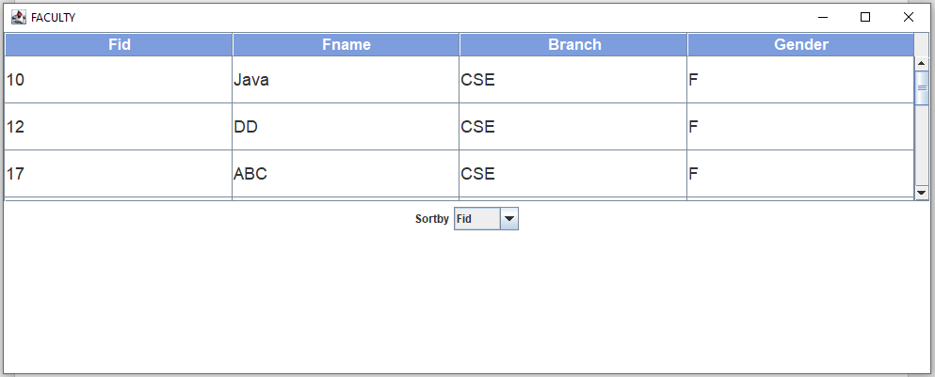

**Using sort by:**

Eg: When sorted by topic

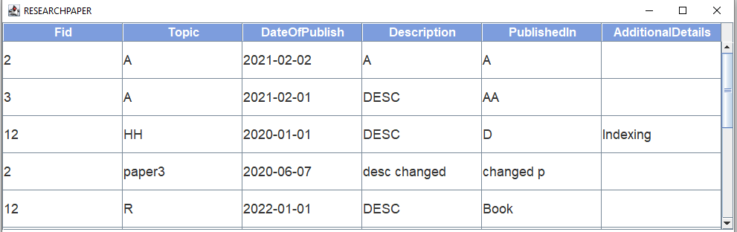

**E)Update**

1.When submit is clicked without entering any data.

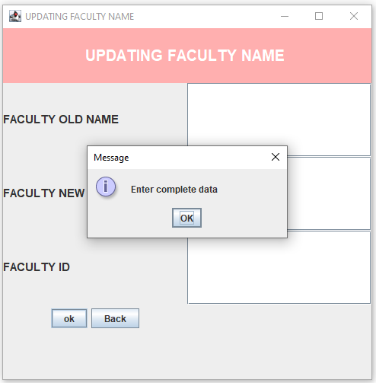

2. When data trying to be updated does not exist in the table

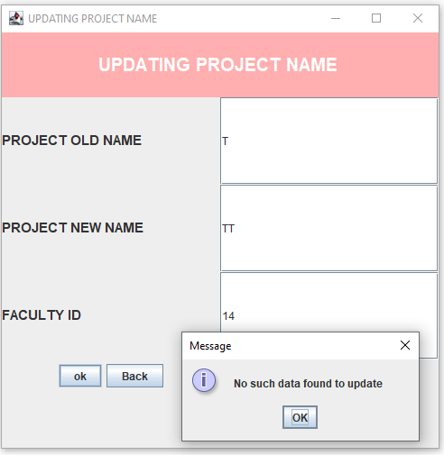

3. When data trying to be updated exists in the table

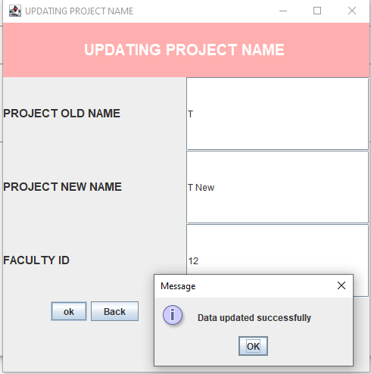

**VII.Conclusion :**

Maintenance of data, updating it and tuning the information is convenient with the help of the software. Human intervention in maintenance of the data is kept to minimum by the use of the software. Difficulties of maintenance of paper work and periodic references of files for dealing with inaccuracies are easily tackled as the software provides all the data in a single click. Faculty,Patent ,Project and Research data are clearly segregated in the database and in the visualization part. Thus, data is channeled and organized. Handling the interface is more convenient than the traditional recording techniques since the data is not scattered. Therefore, the application provides a better interface by tackling all the problems experienced in traditional techniques.